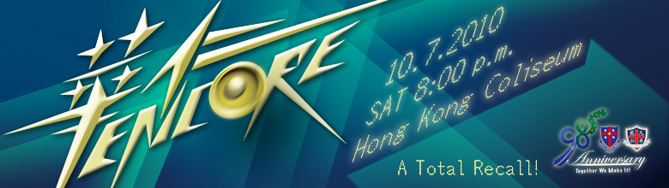
Dear Classmates of WYK1980,

This year is the 85th Anniversary of Wah Yan Kowloon. The "Wah Yan Encore Concert" will be the grand finale to the 90/85th Anniversaries Celebration Programme for the two Wah Yan Colleges. It will showcase the essence of performing arts emerged in the histories of Wah Yan. More than 800 alumni, teachers, parents, current students and our friendly schools will be performing in the evening of 10 July, 2010 at the Hong Kong Coliseum.

I was informed by the organizing committee that the class of WYK1980 can sit together if we gather enough classmates and friends (about 50 X $100 tickets, well, I will argue with them if we are close to it).

Please let me (jng@comp.hkbu.edu.hk or 9866-0315) know as soon as possible how many tickets you want and I will order them for you. We look forward to welcoming you that evening.

Detailed Event Information
Date: 10 July, 2010 (Sat)
Time: 8:00 p.m.
Venue: Hong Kong Coliseum
Price for WYK1980: $100 per ticket
Price for other seats: HK$50, $500, $2,000 per ticket

I will keep everybody informed about who is attending the Wah Yan Encore Concert through the WYK1980 Announcement Page - http://josephng.hk/WYK1980/

Best Regards,

Joseph Ng Kee-Yin (K.K.)
WYK1980

Related Links:
WYK1980 Announcement Page - http://josephng.hk/WYK1980/
Ticket Ordering & Sponsorship Form - http://www.wahyanonefamily.org/doc/aeEncoreBook.pdf
Seating Plan - http://www.wahyanonefamily.org/doc/encore_seating_plan.pdf
Advertisement on Ming Pao & Sing Tao - http://www.wahyanonefamily.org/images/encoreFPad.jpg

